**FINAL EXAM SOLUTIONS**

Q-1. You have 5 bowls containing, respectively, 10, 10, 10, 20 and 30 balls. Some balls in each bowl are white; the rest are black. The number of white balls in the bowls are, respectively, 7, 3, 8, 7 and 15. A bowl is selected at random, and a single ball is drawn from that bowl at random. It is found that the ball drawn is **black**. Find the probability that the drawn **black** ball came from bowl #2.

From the given data, we get the total number of BLACK balls in the five bowls = 40.

P( bowl-2 | black-drawn )

= P( bowl-2 & black-drawn ) / P( black-drawn )

= P( black-drawn | bowl-2 ) * P( bowl-2 ) / P( black-drawn )

= [ 3/10 * 1/5 ] / [ 40/80 ] = **(3/50)/2 = 0.03**

Q-2. A fair coin is tossed 8 times. Find the probability that it turns up HEAD exactly 3 OR 4 times.

N = 4

**Q-2 Answer = [ 8CN-1 + 8CN ]/256**

Q-3. The average working life of a certain power supply is claimed to be 10000 hours, with standard deviation of 400 hours. We test a sample of size 25 of the power supplies, and calculate the sample mean. Find the probability that the sample mean is between 9800 and 10200 hours.

**Answer:** 400/5 = **80** 🡪 standard deviation of sample mean

So number of standard deviations on either side = 200/80 = 2.5

So answer = **2*F(2.5) – 1, where F(z) is the standard normal cdf**

Q-4. Five pairs of values of random variables X and Y are tabulated below. Find the COVARIANCE of Y & X.

|  |  |  |  |  |  |
| --- | --- | --- | --- | --- | --- |
| X | 1 | 2 | 3 | 4 | 5 |
| Y | -4 | -3 | 0 | 3 | 4 |
| X - mean | -2 | -1 | 0 | 1 | 2 |
| Product | 8 | 3 | 0 | 3 | 8 |

**Sum of DX*DY product = 22 🡪 answer = 22/5 = 4.4**

Q-5. Trucks arrive at a toll booth at the average rate of 12 arrivals per hour, and the arrivals define a Poisson process. What is the probability that the time interval T between two successive arrivals, measured in minutes, satisfies 4 < T < 6?

**Answer: e-M/5 – e-N/5**, since the rate of arrivals is 1/5 per minute.

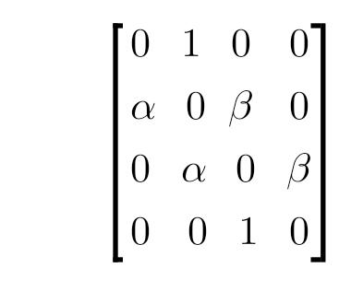Q-6. Recall the Markov process defined as "random walk with reflecting barriers". The four states of the process are 1, 2, 3 and 4. The transition probability matrix is as given below, with a = M/10. The initial probability distribution over states is (0, 1/2, 1/2, 0). What is the probability that the process is in state 1 after two time steps?

**Pre-multiply TWICE above matrix with the probability matrix. After one pre-multiplication, probability distribution = ( a/4 (1+a)/4 (1+b)/4 b/4 ). After the second round, only the first element of the row is needed, so only one column multiplication is needed.**

**So answer = a(1+a)/4 = (M/10)*(1+M/10)/4 = M*(M+10)/400**